Unit 2: I wonder what it’s about.

Speaking:
- Describing shows and celebrities

Grammar:
- Indirect questions

Reading:
- Staying successful

Warm-up
- What do you watch on TV or online?

Making a list is helpful when planning for speaking practice.

For this topic, consider TV shows, movies, online streaming platforms (Netflix), YouTube…

Professor’s example:
- I can’t get enough of British crime series.
  - Inspector Morse
  - Midsomer Murders
  - Pie in the Sky
  - Touch of Frost

- Online… I watch cooking shows…
  - MasterChef
  - Hell’s Kitchen, Kitchen Nightmares
  - Guy’s Grocery Games
  - Diners, Drive-ins and Dives

Vocabulary
- Find examples of each type of genre.
- Briefly write (1-2 sentences) which genre is your favorite and why.

Discussion:
How do you show politeness and formality in your language/culture?

How is politeness and formality expressed in the English language?

- Conversation topics... approach is cultural...
- Titles, position... Professor / Doctor / Director / Sir / Miss / Ma'am
- Please, thank you + yes please
- Eye contact, nodding the head, shaking hands
- Greetings
  - Good morning, afternoon, evening = most polite
  - Hey = ya
  - Hello = phone greeting
  - Morning! Afternoon!
- Excuse me (USA)/ sorry (UK)
- Indirect questions...
  - Can, could, would, may

Grammar
- Indirect Questions
  - How to not sound rude!
- Purpose? Politeness
- In English, indirect = polite
- How? Add words that reduce the stress on what, when, where, why and how…
- Word order changes at times (= is)

Video Tutorial: https://www.youtube.com/watch?v=qFhe2OmO4dg
More Practice: https://www.e-grammar.org/indirect-question/test1-exercise1/

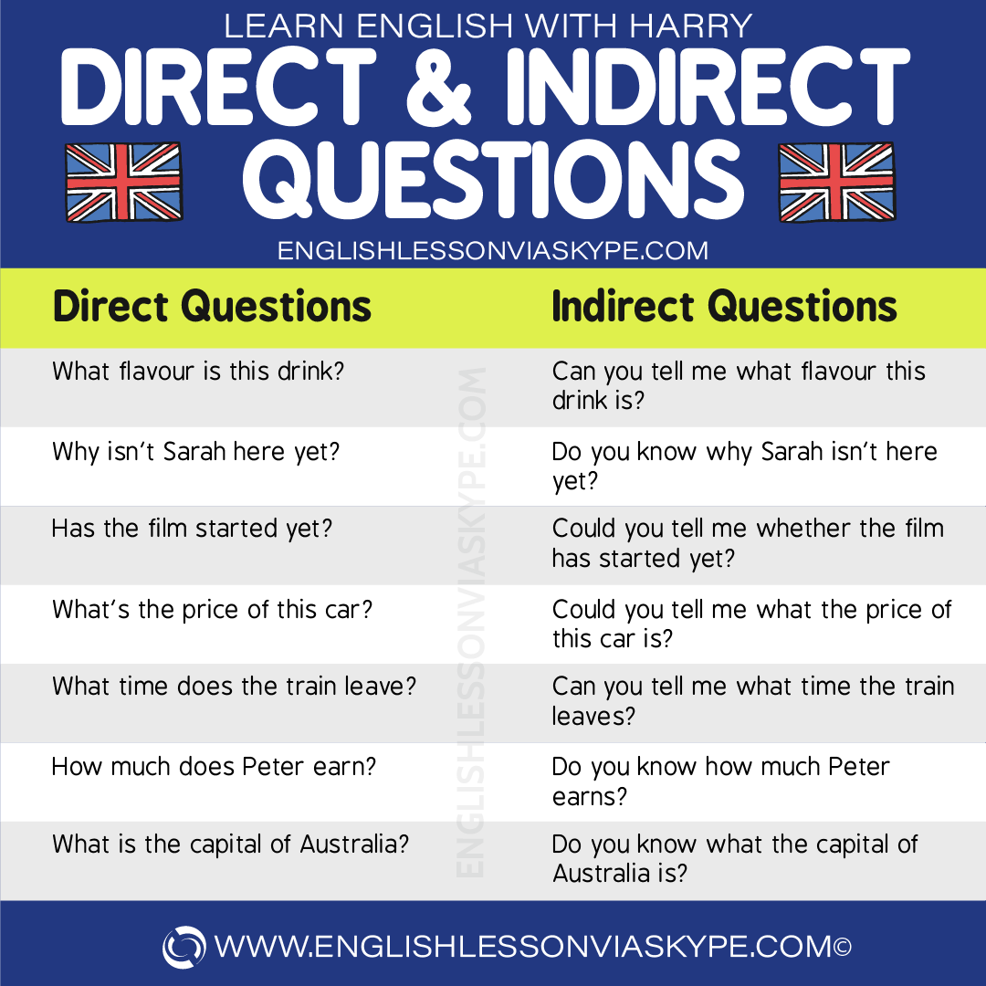

Extra: What are other ways English speakers modify language to express respect/politeness? (HINT: Other grammar points in our text help express politeness?)

Video Expansion (optional):
- https://www.youtube.com/watch?v=aRbaIHNttv4

Reading

Conversation Questions

- Which movie would you like to live in?
- What’s the best movie you’ve ever seen?
- Do you prefer watching movies at the cinema or on TV?
- Which country makes the best movies?
- Who are your favorite movie stars (and why)?
- What’s the worst movie you’ve ever seen?
- Are movies good for us?
- Do you think movies make people more violent?
- What movie genre do you like best?
- Which actor would you want to play you in a movie about you? Why?
- Do you prefer to watch a good movie, a good documentary or a good game of sport?
- Who do you like watching movies with best?

Want to link the grammar practice with conversation? Try to re-write the direct questions as indirect questions.

